Jenkins Pipeline and Jenkins File

# What is Pipeline:

# What is Jenkins Pipeline:

* It is a way or process to perform CI-CD.
* CI-CD means continues integration and continues deployment.
* Like the build > deploy > Test > Release.
* From build to release we use the Jenkins Pipeline for CI-CD.

# What is Jenkins file:

* In this we write a code/script to implement the Pipeline to run all the stages(Build > Deploy > Test > Release) correctly.
* A Jenkins file can be written in two type of syntax – **Declaration and Scripted** both are written in Groovy but have a different structure.
* The **Scripted way** is old kind of technique to write a script but he **Declarative way**  is new kind of technique to write a script.
* **Scripted ways:**

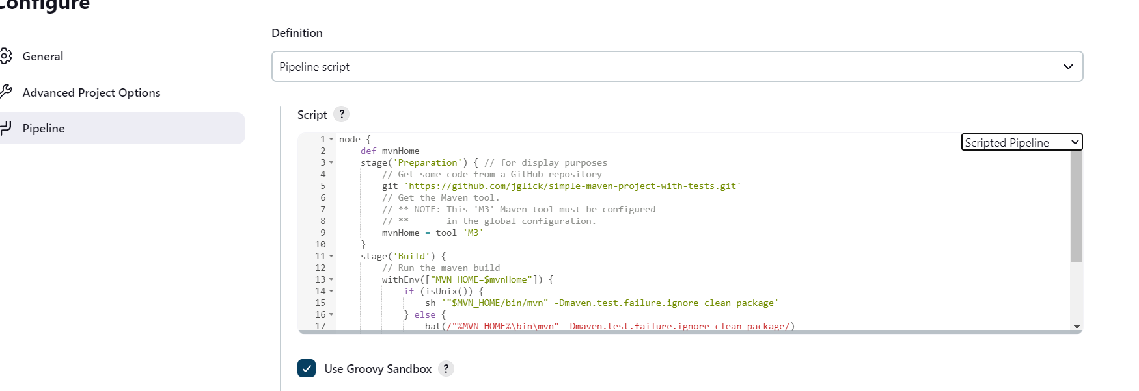

Looks like this.

# How to create Jenkins file:

1. Start your Jenkins.
2. Install pipeline plugin.
3. Create new jobs.
4. Create or get Jenkins file in Pipeline section.
5. And now run and check the output.

# How to get Jenkins file from git:

1. Create a new Job or use existing Job (type: pipeline).
2. Create a repository in GitHub.
3. Add Jenkins file to the Repository.
4. Under Jenkins job > Pipeline section > select Pipeline script from SCM.
5. Add repository and Jenkinsfile location in the job under Pipeline section
6. Now save and run.

# How to clone the Git Repository using Jenkins file:

1. Open the Job (type: pipeline)
2. In the definition section select Pipeline script
3. Then click on pipe line syntax
4. Not in steps section select git
5. Then all the credential.
6. Now click on the generate pipeline script and copy what generated.
7. Then paste that into “Script ?” .
8. And apply and save.
9. Click on build.